Style Guide

Swamp

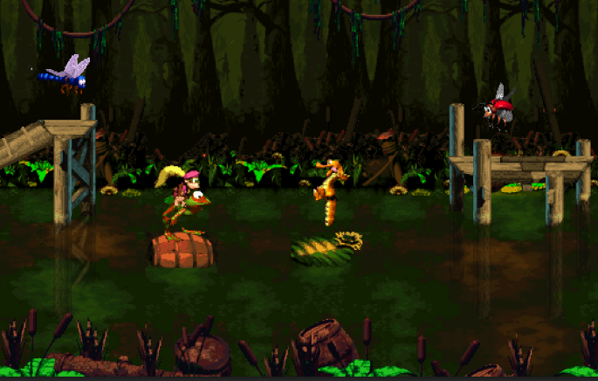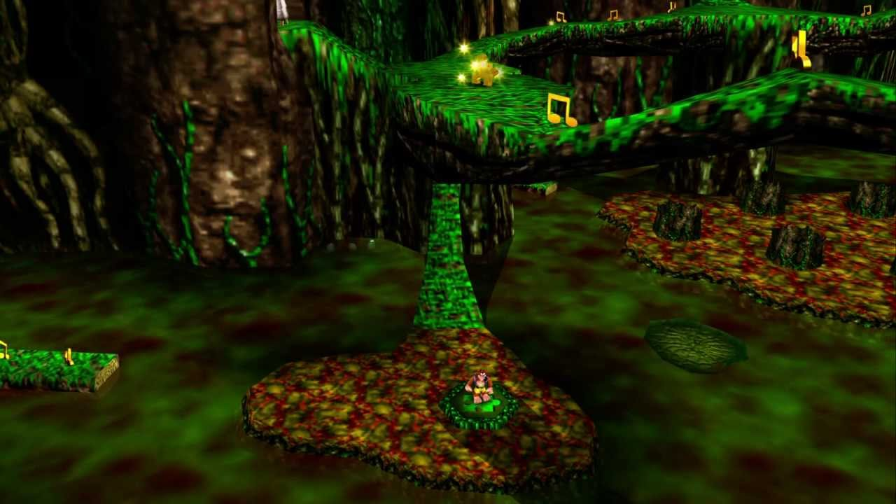

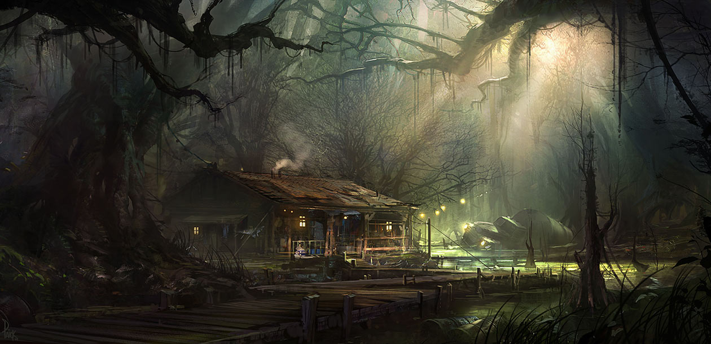

Colors: dark green, brown, red, yellow

Ragged trees

Large trees in background, like left side of third reference picture

Platforms will be mainly wooden walkways and tree roots

Lighting is dark

Temple

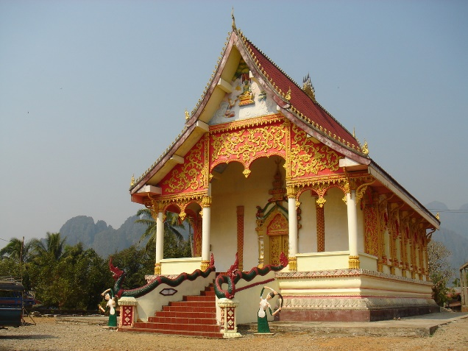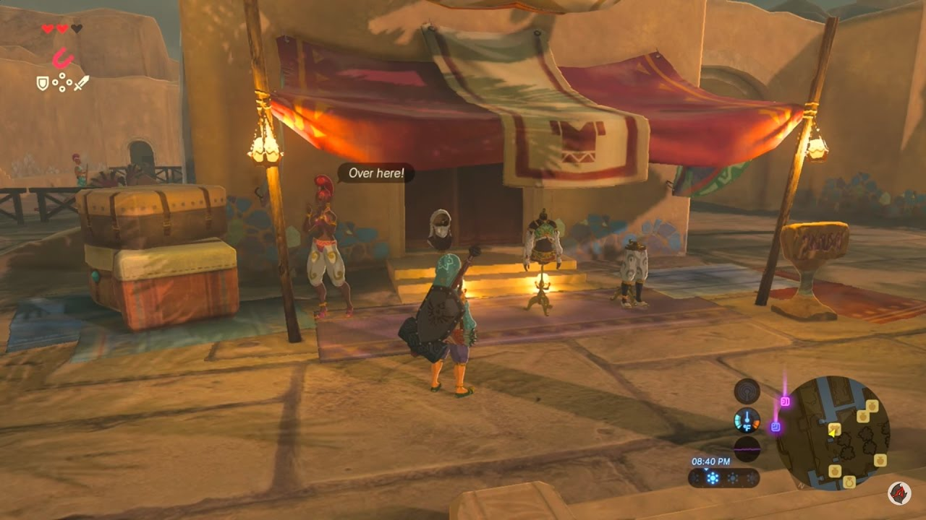

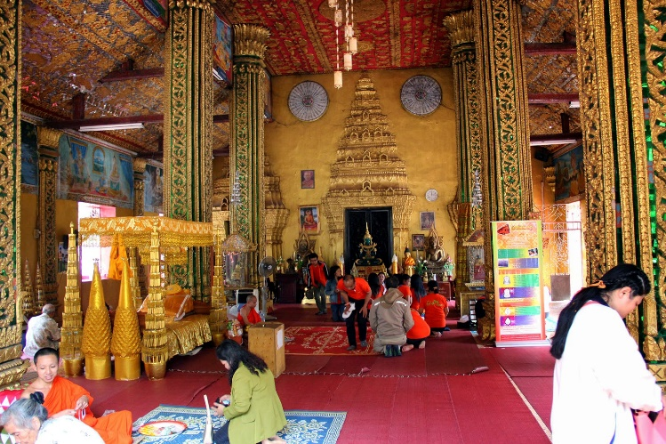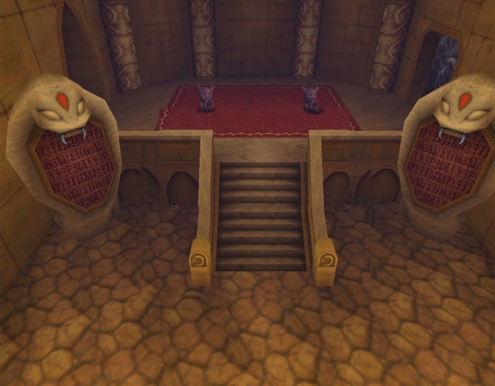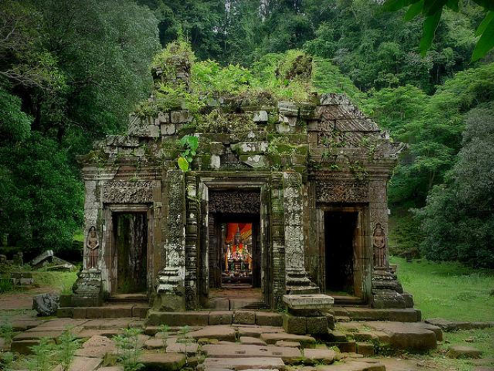

Colors: tans, yellow, red, white

More angular, chiseled look, manmade

Rough, worn out textures

Statues, tapestries